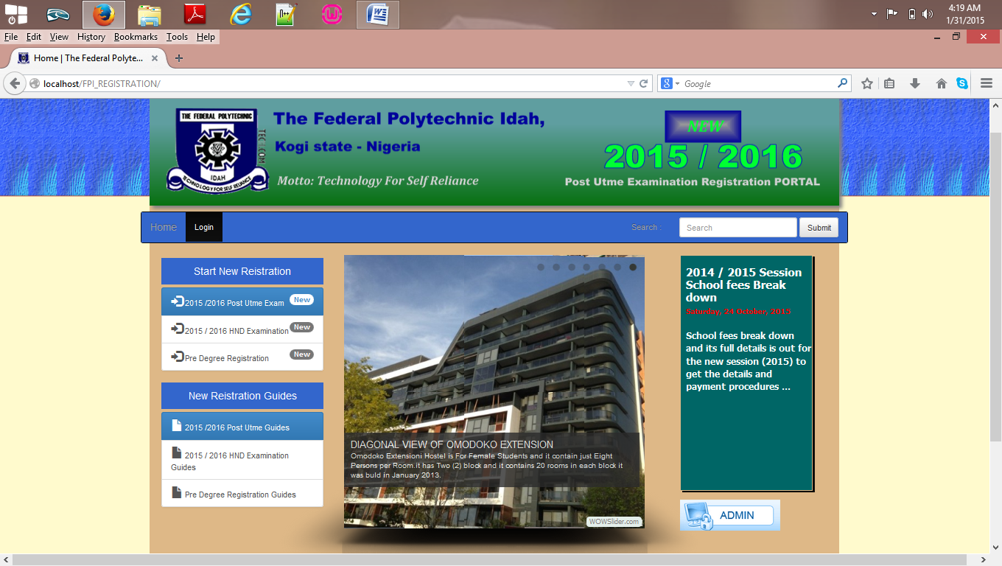

**HOME PAGE**

**BANK PAYMENT ACTIVATION PAGE**

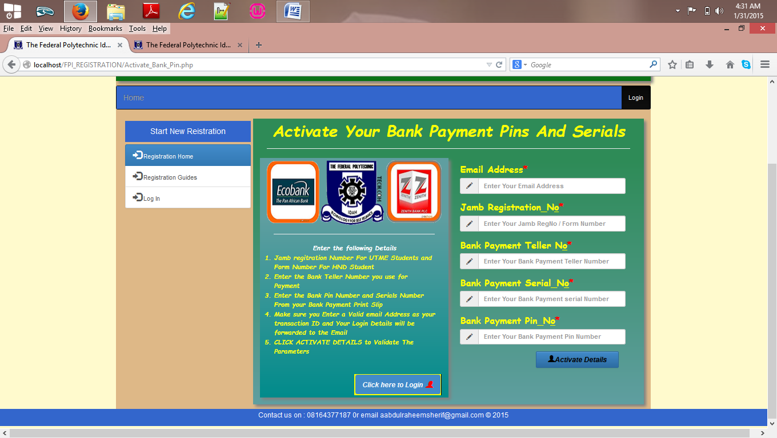

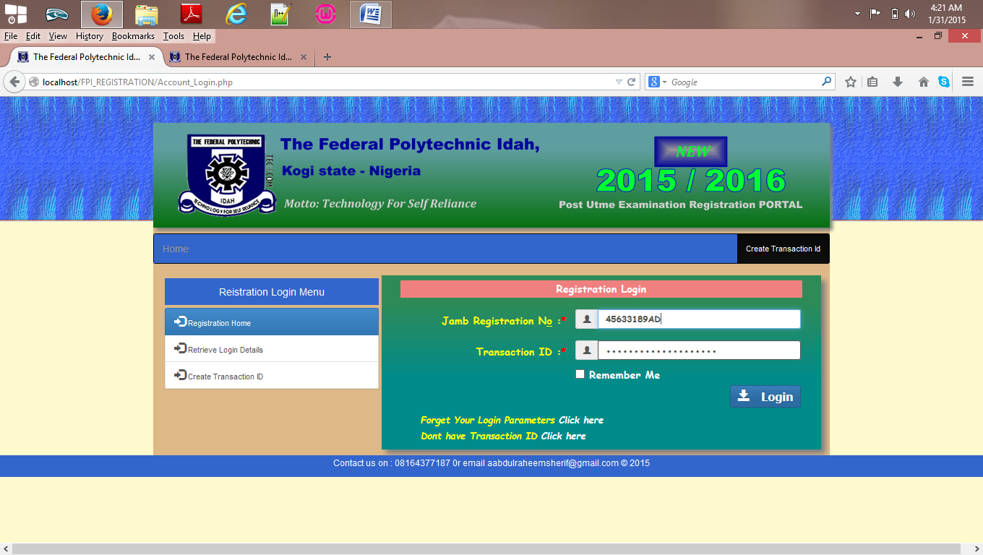

**STUDENT PROFILE LOGIN PAGE**

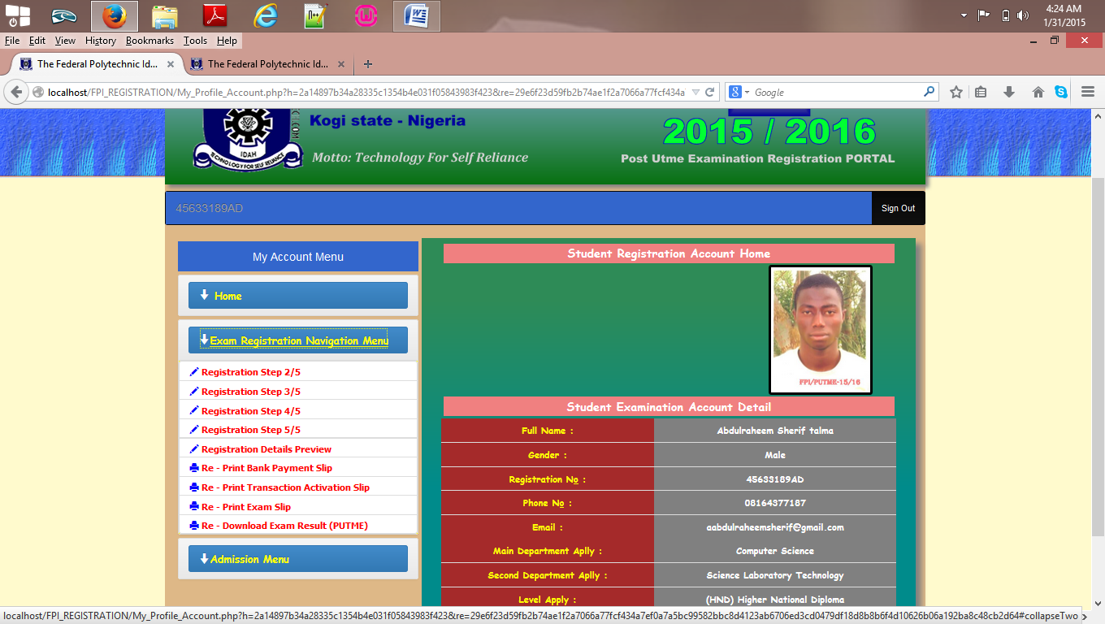

**STUDENT PROFILE HOME PAGE**